Task 1 N=3

Source Code for N=3

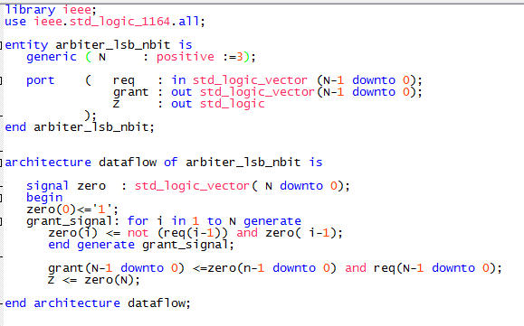

Analysis and Synthesis for N=3

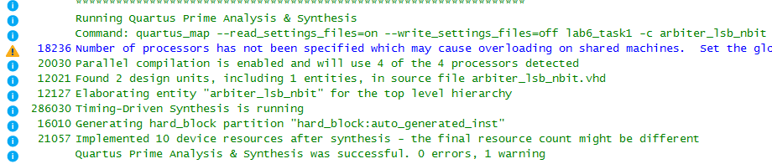

Functional Simulation When N=3

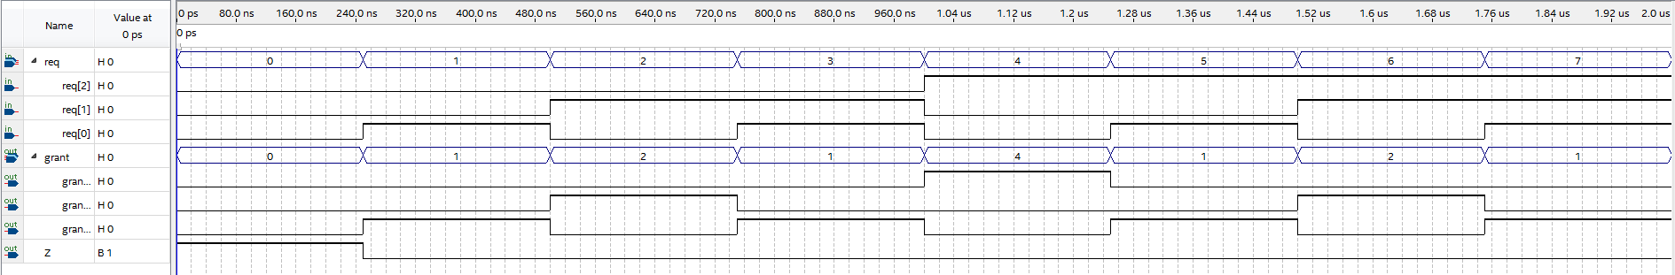

RTL Viewer When N=3

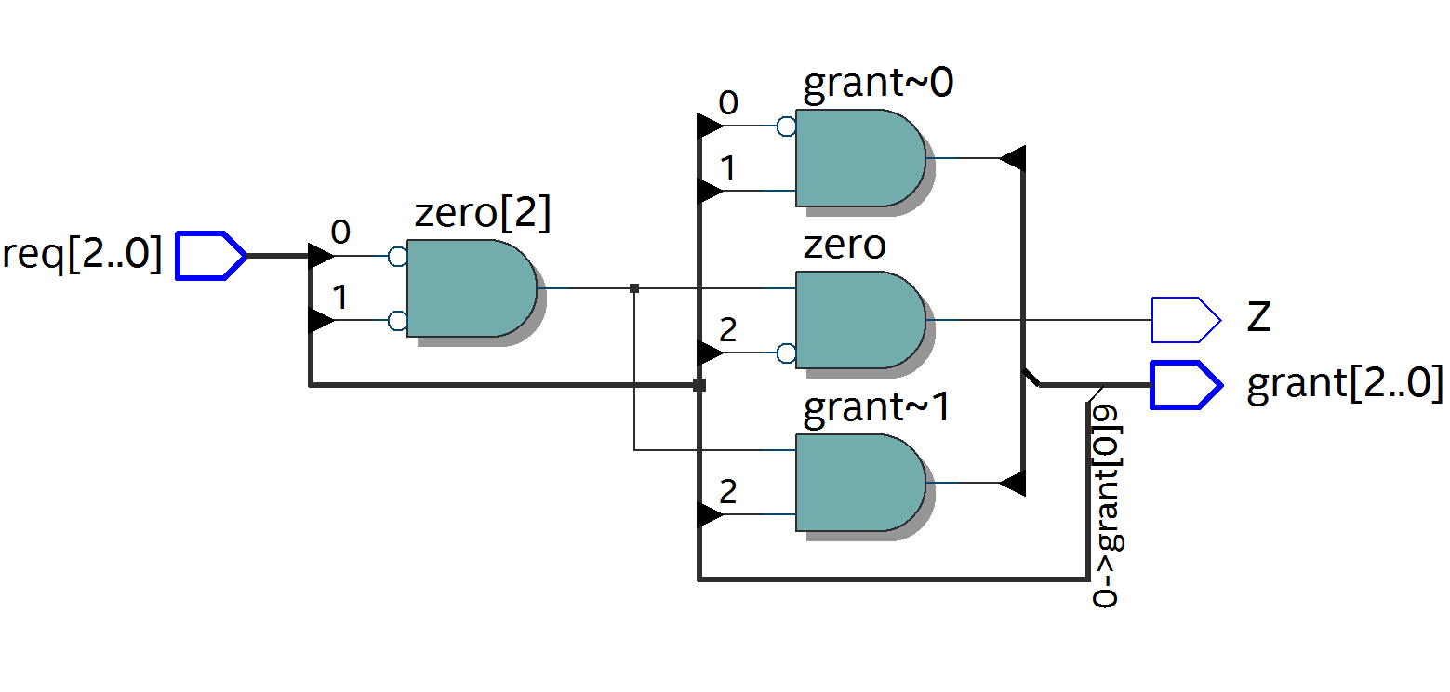

Analysis and Synthesis for N=1



Functional Simulation When N=1



RTL Viewer When N=1

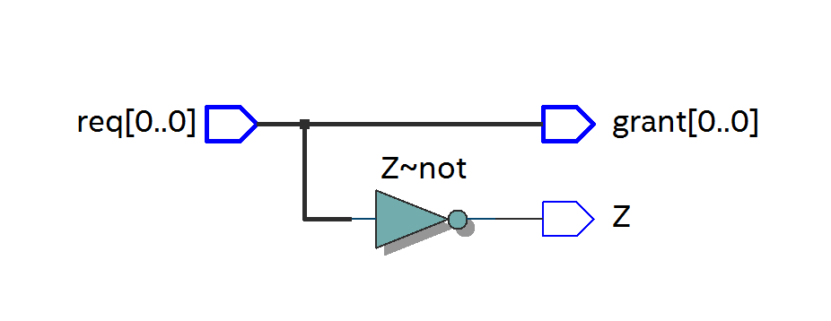

Task 2

Source Code

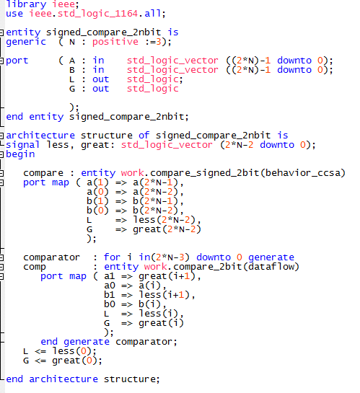

Analysis and Synthesis Message Box for Part 1

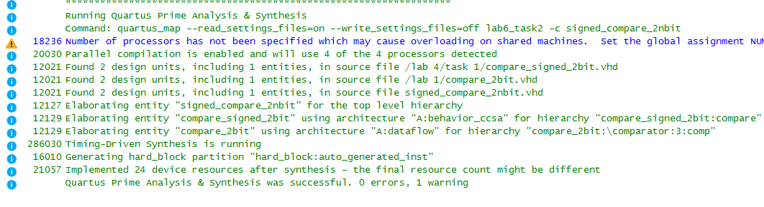

RTL Viewer for N=1

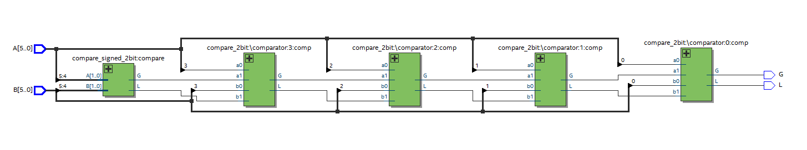

Functional Simulation for N=3



RTL Viewer for N=1

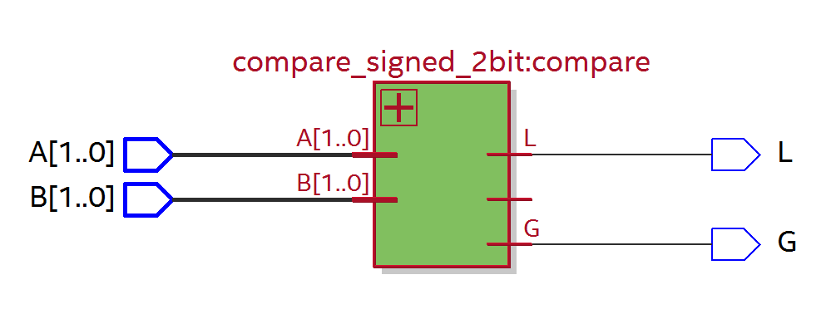

Functional Simulation for N=1



Task 3

Source Code

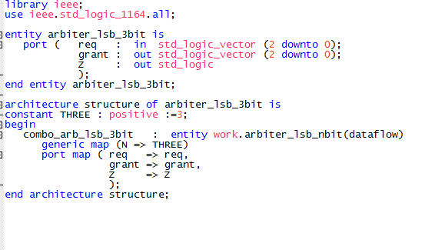

Analysis and Synthesis Message Box

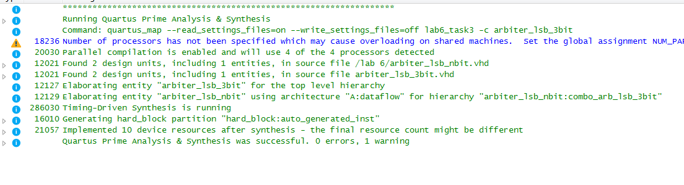

Functional Simulation

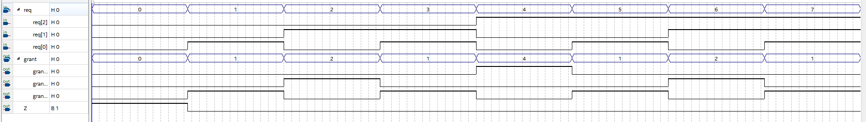

RTL Viewer 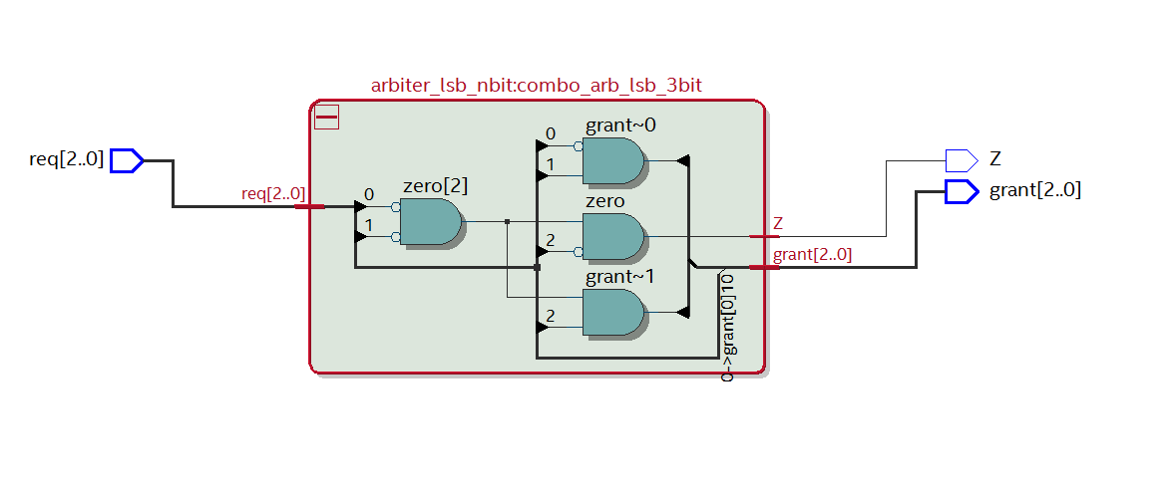

Full Analysis Message Box

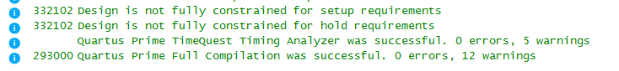

Timing Simulation

